**Brooklyn torah gazette**

**For parshas mikeitz 5781**

Volume 5, Issue 16 (Whole Number 216) 4 Tevet 5781/ December 19, 2020

**Printed L’illuy nishmas Nechama bas R’ Noach, a”h**

This means, if one doesn't provide food to those who need it, he is held responsible for everything wrong that happens due to this error.

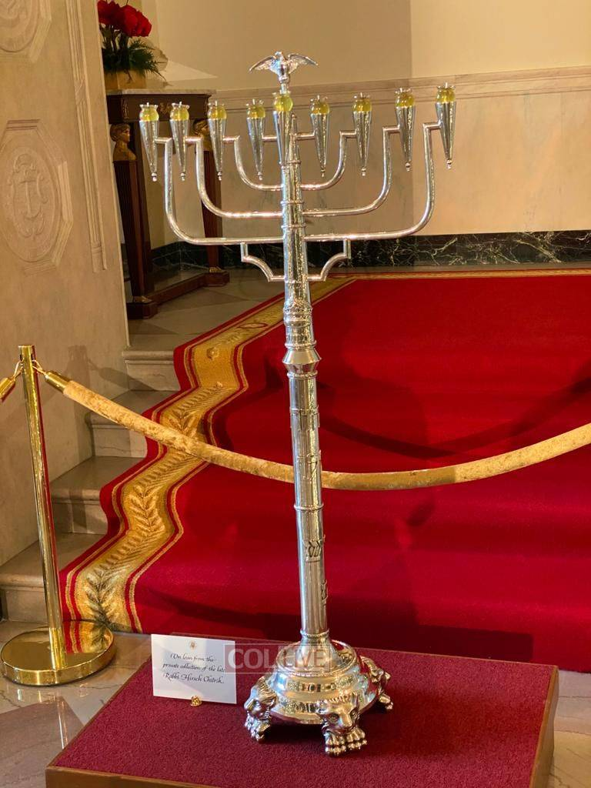

***A silver menorah adorned with an eagle was loaned to the White House for the annual Chanukah party on December 9th by the family of the Crown Heights jeweler Rabbi Hirsch Chitrik OBM; President Donald Trump offered greetings.***

**Yated Columnist Goes After Consumerism, Meat Boards, Weddings in Dubai and More**

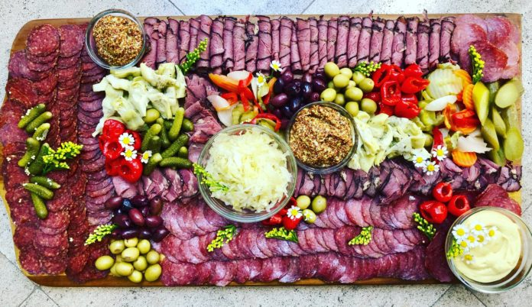

In last week’s Yated Ne’eman, writer Avrohom Birnbaum penned a sharp article titled” We Have Been Hijacked,” first addressing that fact that a “large percentage of our community of *chareidim l’devar* *Hashem* are prisoners…to our phones and devices. Nothing is sacrosanct, not *davening*, not learning, not talking to our spouses, not focusing on our own children.”

Rabbi Birnbaum then address “consumerism in our communities” that is “so powerful that if you would ask a child or a teen in today’s world what *Chanukah* is all about, he could not be blamed if he answered that it was all about gourmet donuts and meat boards!”

What we are seeing, says Rabbi Birnbaum, “is the legitimization of a lifestyle that is the antithesis of everything for which a Torah *Yid* stands.”

He asks, “A groaning meat board with more than ten cuts of succulent meat, highlighting the color, the ‘marbleizing,’ the oozing of gravy that would put the *matamim* that Eisav enjoyed to shame…is that shameless pursuit of one more fantasy to tickle one’s well developed palette not a *nevalah*? Why is that breach tolerated and lionized in some quarters of our community? It is obscene. There is no more charitable word that I can think of.”

**Displays of Unfettered Pursuits of Gashmiyus**

These displays of unfettered pursuits of *gashmiyus* at a level of “sophistication” that would have been simply unheard of or even unthought of as recently as ten years ago, or even five years ago, are the new normal, he says. A teen today doesn’t even think of it is a “new” normal. It is just normal.

“Do we realize where we are? Where we are going? Ads for ‘encrusted’ and ‘infused’ cuts of meat and steaks that cost $40 and $50 a pound are in our publications. We are putting the *Yevonim* to shame. I am almost certain that even Antiochus couldn’t get his hands on a charcuterie that any *bochur* can get if he knows the right party to crash.

Why are we not equally *ekeled*, or disgusted, by that shameless show of indulgence as we would be disgusted by, and would rightfully protest, reprehensible images? This is not a *kedoshim tihiyu* issue. It is far worse. It is a *nevalah b’Yisroel*, nothing less, and we have to say it the way it is. Again, I am speaking about the shameless way it is promoted, not about what meat one eats in the privacy of his home.”

Rabbi Birnbaum goes on to address one final issue: weddings in Dubai.

“These weddings are extremely upscale affairs featuring well-known singers, *roshei* *yeshiva* being *mesader* *kiddushin*, and every indulgence that you can’t even think of. Top it off with white-robed, *kafia-*wearing waiters obsequiously serving the Jewish masters of the affair… How do we unpack so much at once? Yes, it is wonderful that there is peace with more Arab countries, but *rabbosai*, are hotels in the Virgin Islands, the Swiss and Austrian Alps and the French Riviera not enough for us?

**A New Danger of Assimilation**

Now we have an unending stream of visibly *frum* *Yidden* going to Dubai, Bahrain and who knows where else. Have we forgotten the *pereh* *adam*, *yado* *bakol*…? Do we now have to add the threat of assimilation with Arab nations to the problems that we already have?”

“…These images of obsession with self-indulgence make their way around the groups, where it is even more normalized and it becomes less shocking for anyone who has a *Yiddishe* *hergesh*. Then it starts to show up on what are ostensibly ‘*frum* websites,’ and when they are even more normalized, they begin to appear in *frum* print publications.

The more responsible *frum* print media outlets have a very difficult time maintaining standards, as the bar is collectively lowered and people get accustomed to the ‘new normal.’ What is the final stop? These items, whether they are bottles of wine worth hundreds of dollars or cuts of meat that until recently you never heard of, become so normalized that they end up being served at the parlor meeting for a *mosad*, while the speakers lecture about the beauty of *hachzokas* *haTorah*.”

How, Rabbi Birnbaum asks, are we supposed to bring up children who are *ovdei* *Hashem* in this environment when everything about it screams *Yovon*?

“We have been hijacked by a vocal, glossy, shameless minority.” He concludes, “It is time to fight back.”

*Reprinted from the December 14, 2020 website of Matzav.com*

**Menorah Power**

**By Rabbi Moshe Meir Weiss**



Many people know of my proud affiliation with the outreach organization Oorah. Since its inception in the 1970s, I’ve had, in a very humble way, a connection to the holy kiruv work of Rav Chaim Mintz, Shlit”a, the Mashgiach of the Yeshiva of Staten Island.

Some of my readers might have heard me on the very popular Oorah radiothon. But today, let me share with you an Oorah story which dates back to the 70s that changed my appreciation ever since of the Chanukah Menorah’s power.

**What Can a Small Menorah Really Accomplish**

Before doing so however, let me raise a question with which many a modern day youth might struggle. That is, What can the small menorah, placed in a window, really accomplish? It seems totally dwarfed by superior lighting all around it, whether the LED bulbs of the outside streetlights, or the incandescent, florescent, halogen or maybe even mercury vapor lights indoors. What impact can these flimsy wicks and a small puddle of oil really accomplish?

Now let me share with you a true Oorah anecdote. I once went out with Rabbi Mintz in the car on Chanukah on one of his quests to find Jewish children who are not yet privileged to be in yeshiva. Rabbi Mintz would drive the car almost aimlessly looking in uncharted territory for a Jewish home ripe for his overtures of kindness and inspiration.

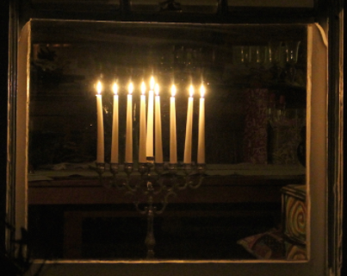

You must understand that the Staten Island of the 1970s was quite different than it is today. There was no West Shore Expressway and a mere decade after the Verrazano-Narrows Bridge was built, there was no Staten Island mall. Rather, in its place were a few fruit stalls. I remember when my father, of blessed memory, drove me to yeshiva, he would stop out there to buy fresh corn.

How, might you ask, in the middle of Italian neighborhoods would Rav Mintz be able to discover and ferret out Jewish families? Ahhh! There’s the secret! That’s why he went out on Chanukah! He would put up his “periscope” and hunt for a menorah of any kind in one of the windows.

When he would joyfully spot one, he would park the car and, armed with beautifully gift-wrapped toys, he would ring the bell. Now, I’m talking about state-of-the-art gifts. I remember that somehow he had Cabbage Patch dolls when they were on back-order for two months. He had space invader technology when that was the total rage of the day.

When the parents would come to the door, he would wish them a Happy Chanukah and ask if they had a young child. When they said ‘yes,’ he would ask whether he could please come inside in order to give a Chanukah toy. Who could resist such an offer?

When the child would gleefully open the Cabbage Patch surprise, the stage was set and Rabbi Mintz would pop the question to the parents, ‘Where does your child go to school?’

When they answered Public School, he would ask in amazement, ‘Why don’t you send your child to yeshiva because, after all, that’s where a Jewish child belongs?’ Inevitably, they would say that they couldn’t afford it and he would offer them financial assistance on the spot.

That’s how Oorah was born. Today they have multitudes of children in over eighty yeshivas and wonderful camps for boys and girls of many ages. But to me, there is an amazing Chanukah lesson here. If you own a Cadillac, you can enroll in the Onstar System. One of the perks of this plan is that, if the car gets stolen, it sends out a signal so that the police can trace it and zoom-in on the missing car



**Rav Chaim Mintz**

**. The Menorah Clearly Acted Like an Ancient Onstar System**

When I saw Rabbi Mintz in action, the menorah clearly acted like an ancient Onstar System, sending out a signal like a beacon, helping him zoom-in on lost Jews to help to bring them back to the traditions of their ancestors. These flimsy wicks and small reservoirs of oil pack an awesome power that range over the millennia just as they represent the spiritual rescue of our Jewish ancestors during the era of the Syrian-Greeks when there was a very grave threat of Hellenization and assimilation. The wondrous menorah, thousands of years later, is still diligently fulfilling its task of rescuing precious Jewish souls.

Anyone wanting to be a part of the Oorah family can call the Oorah hotline at (732) 730-1000 and become a part of one of their very fulfilling programs. Perhaps you would also like to knock on a door that has a menorah in the window. Maybe you would like to adopt an Oorah family, becoming its Jewish spiritual mentors. Perhaps you would like to take part in an Oorah Shabbaton. If you would like to help finance Oorah itself, then 877-7-AUCTION is the number you want.

May the glorious Chanukah menorah mitzvah, together with the awesome zechus of Oorah, help us to be blessed with a healthy, happy, wonderful, and COVID-19 safe winter.

*Reprinted from the December 7, 2020 email of The JEWISH VUES.*

**Rabbi Berel Wein on**

**Parshat Mikeitz 5781**

**

The dreams of Joseph are actualized in this week's Torah reading. Miracles, though hidden, are somewhat natural events, and in this instance occur to facilitate this realization of the dreams of Joseph.

We all dream, but not all dreams are miraculous per se. The great Pharaoh of Egypt also had dreams. The fact that he dreamt of fat cows and lean cows is also understandable, for that was the nature of the society that he governed at that time. It was, in the main, a purely agricultural society, dependent upon animal power to produce food and sustenance. It is also not surprising that he dreamt of sheaves of grain, both full and empty.

**These Dreams Repeat Themselves Have**

**An Unusual and Perplexing Conclusion**

But Pharaoh is disturbed by the fact that these dreams repeat themselves, and as Midrash teaches us, these dreams have an unusual and perplexing conclusion to them. In effect, the little destroyed the big, the weak destroy the mighty and the few triumph over the many. These conclusions were in direct opposition to the beliefs and experiences of Pharaoh. When he awoke in the morning and remembered his dreams. he was sorely troubled that they did not conform to any of his previous experiences.

It is this part of the story, the fact that the dreams were the opposite of what they had experienced previously, that sets the stage for the miraculous deliverance of Joseph and his unbelievable rise to power and fame. Thus, we see how miracles are formed by seemingly natural events, with just a little twist to those events that facilitate and hasten the arrival of the miracle.

**One of the More Amazing Insights**

One of the more amazing insights into this dramatic turn of events is that it seems that Joseph is not at all surprised by his being taken out of the dungeon and placed upon one of the thrones of the ancient Egyptian Empire. Simply being released from prison after having the aristocracy of Egypt against him, one would think this would have been a sufficient miracle for this lonely, defenseless Jew accused of a serious crime, Yet, from the way that Joseph immediately gets to work to store food before the famine, it seems that he knew that he was destined to be part of history. It was as if he almost expected to be appointed as the ruler of Egypt, second only to the Pharaoh.

In the house of Jacob, as in the houses of Isaac and Abraham, miracles were part of everyday life. They were expected to happen because our ancestors lived in a world of the spirit, where the presence of Heaven always felt real. Joseph had no doubt that he would be saved, and that his dreams of greatness and accomplishment were not made of imaginary straw.

He only did not know how this would come about and how the dreams would be actualized. He had intended to be helped by the butler of Pharaoh, but that was not the track that the Lord had ordained for Joseph. In this week's Torah reading, the real story unfolds with all the necessary twists and turns that make up human life.

*Reprinted from the website of Rabbiwein.com*

**How the Jews Can Reach**

**Higher Levels of Spirituality**

**Even When in Exile**

**(Lands of Affliction)**

**From the Talks of the Lubavitcher Rebbe**

**Rabbi Menachem Mendel Schneerson, Zt”l**

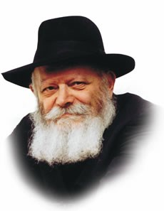

What is the reason for the Jewish people being in exile? What purpose has been served by almost two thousand years of suffering and hardship?

The answer to this age-old question is alluded to in this week's Torah portion, Mikeitz, in Joseph's explanation of his choice of name for his son Ephraim.

"The name of the second he called Ephraim," the Torah states, "for G-d has caused me to be fruitful ("hifrani" -- from the same root as Ephraim) in the land of my affliction."

In other words, it is precisely through exile "in the land of my affliction" that Joseph became stronger. Likewise, the entire purpose of exile is to uncover the Jewish people's hidden strengths, bringing them to a higher level of perfection.

On a personal level, Joseph had attained the highest rungs of spiritual service, standing head and shoulders above his eleven brothers; in a certain sense, he was even superior to his father Jacob. Nonetheless, in order to attain the very highest levels, Joseph had to undergo exile "in the land of my affliction."

**Joseph’s Exalted Spiritual Status**

**In Comparison to His Brothers**

The Torah alludes to Joseph's exalted spiritual status in its statement that the brothers "recognized him not." According to Chasidic philosophy, Joseph's involvement in worldly matters was perceived by them as an obstacle to spirituality.

The brothers couldn't understand how a person could be worldly and serve G-d at the same time. Thus they deliberately pursued a life of contemplation; as shepherds, they were cut off from civilization and the demands of society. Never in their wildest dreams could they fathom how Joseph, second-in-command over all of Egypt, could remain connected to G-d and indeed surpass their level of service. The concept itself was too radical for them to grasp.

Joseph's superiority to his father is also reflected in the fact that he was punished for putting his faith in Pharaoh's butler, whereas when Jacob addressed his brother Esau as "my master," it was not considered a sin.

**A Difference Between Joseph and His Father Jacob**

Jacob, despite his great spiritual attainments, was still subject to the limitations of the physical world and thus permitted to work within the natural order; Joseph, however, was above such constraints and therefore held to a much higher standard of behavior, according to which he should have placed his trust in G-d alone.

Nevertheless, we see that it was only through the experience of exile that Joseph was able to attain the very pinnacle of spirituality, paving the way and setting an example for his future descendants.

For just as the Jewish people merited to receive the Torah after the "crucible" of the Egyptian exile, so too will we merit the very highest revelations of G-dliness with the ultimate Redemption.

*Reprinted from the Parshat Mikeitz 5756 edition of the L’Chaim Weekly, a publication of the Lubavitch Youth Organization. Adapted from Sefer HaSichot of the Rebbe, Vol. 1.*

**Parshas Mikeitz**

**A Generous Spirit**

**By Rabbi Bentzion Shafier**

**Founder of TheSmuz.com**



“*And from the Nile rose up seven cows beautiful of appearance and healthy of flesh*.” — Bereishis 41:2

Pharaoh had a dream. First, seven “good” cows came out of the Nile. Then seven “bad” cows came up and consumed the first cows. When he awoke in the morning, he called for Yosef to interpret the dream. Yosef explained that the seven “good cows” represented the seven years of plenty that would then be followed by seven years of famine. Interestingly, the expression the Torah uses to describe the first set of cows is, “beautiful of appearance, and healthy of flesh.”

Rashi explains that “beauty of appearance,” means that during the seven years of plenty, since everyone would have abundance, they wouldn’t have a jealous eye toward one another, so their neighbors’ possessions would look attractive. During the seven years of famine, in contrast, since they would be lacking, their neighbors’ belongings would look ugly.

This Rashi is difficult to understand. He seems to be saying that because a person doesn’t have, he will become jealous and therefore his neighbor’s possessions will look distasteful to him. It would seem to be just the opposite. If I don’t have something and you do, my not having it will make me want it more, so that item, now being an object of my desire, should look more attractive, not less.

The answer to this question can best be understood through an observation about human nature.

**Seeing Life through Rose-Colored Glasses**

The world uses the expression, “The optimist sees the glass as half full, while the pessimist sees it as half empty,” While there is truth in this statement, it actually goes further. Our attitudes color what we see, and our moods shape our thoughts. Those thoughts become the prism through which we perceive reality. And so, when looking at an eight-ounce glass with four ounces in it, the optimist sees a glass that is full. The pessimist sees a glass that is empty.

Two people can look at an identical situation, yet see vastly different worlds. One sees potential while the other sees pitfalls, one sees obstacles to overcome, and the other sees barriers blocking the path. Because we experience the world through the filter of our attitudes, to an optimist the world is filled with beautiful things and generous people. To a pessimist, the world is filled with ugly things and petty people.

**Learning to See Beauty**

This seems to be the answer to Rashi. When a person has his needs met, he is satisfied, and a satisfied man can be generous of sprit. To a man generous of spirit, the world is a place of beauty. That which my friend has is lovely. His farm is impressive. His flocks are splendid. His crops are outstanding.

However, a person who isn’t satisfied hungers and craves — his needs can cause him to be bitter and stingy of spirit. And to him the world is a place of bitterness and resentment. I begrudge my friend for what he has. I cannot forgive his success. His farm is poor. His flocks are pitiful. His crops are pathetic. The world itself is an ugly place.

**I’ll Be Happy When…**

This concept is very applicable to us. Many people that we meet aren’t happy. The strange part of it is that they have so much, yet something is holding back.

Like a mantra, people utter the words, “I will be happy when…” Each person has his own fill-in for the blank, but whatever it is, his happiness depends on it. It might be the newest car, the fanciest house, the corner office, or the wardrobe worth dying for. It could be the right spouse, acceptance into medical school, that great job, or people who understand me… Each person has his own value system and his own criteria, but he clearly knows, “Once I get it, I will finally be happy.”

**Even Obtaining a Desired Item**

**Doesn’t Make One Happy**

Yet an amazing thing happens. He does finally get it! And lo and behold, he still isn’t happy. What happened? It was all that he needed. It was all that he wanted. He finally has it. Why isn’t he satisfied? What is the problem?

The problem is that it wasn’t what he needed to be happy. The sad part is that he spent years pursuing something with a hunger that didn’t allow him to enjoy life.

HASHEM wants us to be happy. But happiness doesn’t always come naturally.

One of the keys to happiness is the understanding that HASHEM gives each person what is best for him. Not what he wants. Not what he “needs” — but what is best for his situation. This house. This field. This woman.

The Creator of the Heavens and the earth, who understands my inner needs, has chosen this for me. With that appreciation comes a sense of completion. What I have is the best that I could possibly have—for me. I have all that I need.

Now, I see a world filled with good and plenty, a world filled with abundance. Gone is the jealousy. Gone is the bitterness. In its place is sense of generosity—I want you to have all that you can have and more. I am content. I am happy.

*Reprinted from the website of Theshmuz.com.*

**Rabbi Daniel Glatstein Discusses**

**The Tanna Reb Meir Baal Haness**

**By Daniel Keren**

One of the featured speakers at the recent Flatbush Hakhel Thanksgiving Day Yarchei Kallah Event was Rabbi Daniel Glatstein, mora d’asra of Kehilas Ahavas Yisroel in Cedarhurst and author of the ArtScroll books “The Mystery and the Majesty” and “The Light and the Splendor.” He spoke on the topic of Rebbe Meir – “The Tanna You Can Never Forget.”

Rabbi Glatstein began by recalling that the Chidah (Rabbi Yosef David Azulai, zt”l, 1724-1806) writes about the principal of Judaism that since the time Hashem took us out of Egypt, the most important foundation of our faith is that one must always think about the Tanna Rebbe Meir (also known as Rabbi Meir Baal Hanes) who lived in Eretz Yisroel during the second century of the Common Era when the Holy Land was dominated by the heavy-handed and brutal manner of the Roman Empire.)



Rabbi Daniel Glatstein

Rabbi Glatstein asked where will Moshiach reveal himself [when Hashem decides to send him to end our galus, exile?) While many of us perhaps think that the Jewish Redeemer will first be announced in Yerushalayim or Bnei Brak, the Gemara Rosh Hashanah answers that the long-awaited Moshiach will reveal himself in Tiveria (Tiberias). Why? Because that is where the great Tanna Rebbe Meir is buried.

Rabbi Chaim Vital (the foremost disciple of the Arizal) said that while everyone else is according to Jewish law is buried horizontally, the Tanna Meir was buried vertically (standing up,) in order to avoid the trouble of arising from his grave and so he could just walk out to more easily greet Moshiach.

**Greeks Wanted to Separate the Jews from the G-d of Israel**

In connection with the festival of Chanukah, Rabbi Glatstein noted that the Greeks wanted to force the Jews to inscribe on the horn of an ox the words that they (the Jews) have no share in the G-d of Israel.

Rabbi Glatstein said that it is utter heresy to believe that all mankind are the children of G-d. They are creatures of Hashem (tzelem Elokim – made in the image of G-d), but not bonim (children.) Only Klal Yisroel (the Jewish nation) are worthy of being called the children of Hashem.

There is no doubt that the Greeks (creators of philosophy in the Western world) loved the Torah. It was for them a fascinating form of intellectual study. But the Yavonim (Greeks) strongly objected in a Politically Correct manner to accept the Jew’s belief that the Yidden alone are the Bonim (Children) of Hashem.

What does it mean that the Jews are Bonim to Hashem? This, Rabbi Glatstein said, is literal. In just the same way that the biological human father gives his unique DNA to his child, so too does the Ribono shel Olam give a chelek (a spiritual portion) of Himself to Klal Yisroel.



**The burial place of Reb Meir Baal Haness in Tiberias, Israel**

The love of Hakodesh Baruch Hu is so great that He gave us permission to graphically call ourselves the spiritual children of Hashem [as written in the Torah]. What miracle of Chanukah occurred? By the Jews defying the attempts of the Yavanim to nullify our observance of the three specific mitzvahs of Shabbos, mila and Rosh Chodesh; we merited to remain Bonim L’Hashem.

There was a halachic argument (dispute in Jewish law) between Rebbe Yehuda and Rebbe Meir. Rebbe Yehuda declared that if we Jews don’t behave [by properly observing the Torah] we are no longer to be called the Bonim l’Hashem. Rebbe Meir disagreed, stating that no matter what a Jew does we are always considered to be the Children of Hashem.

Rabbi Glatstein noted, that although we never pasken (decide halacha/Jewish law) according to the opinion of Rebbe Meir, the Rashba (Rabbi Shlomo ibn Aderet, 1235-1310) writes that we do so in this case regarding the status of a Jew’s connection as a child to Hashem.

The Yom Tov of Chanukah was the holiday in which Hakodesh Baruch Hu demonstrated that no matter what madreiga (spiritual level) we are holding on, we always remain the Bonim L’Hashem.

Rabbi Glatstein concluded his lecture by quoting Rabbi Chaim Palagi, 1788-1868 who said that we are obligated to never remove from our da’as (mind) the name of the great Tanna Rebbe Meir. At the end of days, the only merit we will have to be redeemed by Hashem with the coming of Moshiach will be through the merit of the great Tanna Rebbe Meir.

To view or listen to the complete 49:16 minute long video of Rabbi Glatstein’s lecture on Reb Meir Baal Haness, click the website of Torahanytime.com, at the top of the homepage select Organizations, scroll down in alphabetical order till you reach Hakhel, click that icon’s details and scroll down to 2020-11-26 “The Tanna You Can Never Forget.”

*Reprinted from the December 18, 2020 edition of The Jewish Connection.*

**The Maccabees, Heroism**

**And Your Children**

**By**[**Dini Harris**](https://www.aish.com/authors/571480771.html)

The story of Hanukkah has all the elements of a best-selling suspense story: Antiochus and his cruel Greek ministers as villains; a suspenseful plot crammed with battles won against enormous odds and the ultimate stakes – the continuity of the Jewish Nation.

And most importantly, the story's heroes: It was the Maccabees who took to the mountains and deserts, gathering other determined Jews around them, and stood up to the Greeks - even though it seemed that they would fight a losing battle.

The Maccabees seem to have been the type of heroes that Hollywood adores; brawny action figures who leap from hideout to hideout, always escaping and outwitting their enemies.

But the Maccabees were not the archetypical heroes that we've been taught to admire in action films.

The Maccabees were not revered by Jewish sages throughout the ages because of their brute strength or physical bravery, and the holiday of Hanukkah wasn’t instituted in order to glorify muscle power or military strategy.

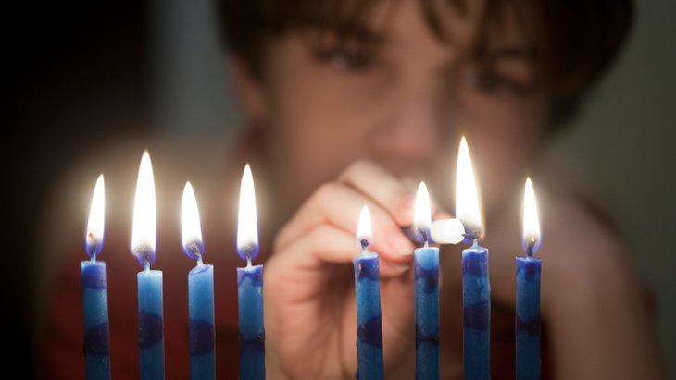

*This Hanukkah, teach your kids how to identify with true heroism.*

**Hanukkah memorializes the spiritual commitment that infused the Maccabees with the determination and conviction that fueled their fight against the Greeks.**

Hanukkah memorializes the spiritual commitment that infused the Maccabees with the determination and conviction that fueled their fight against the Greeks. The holiday commemorates the victory of Jewish spiritual ideals and acknowledgement of the existence of an Omnipotent G-d, over the Greek lionization of "what you see is what exists" and the deification of human intellect.

It's not physical brawn or beauty that we admire; but spiritual ideals and the commitment to do the right thing at the right time, no matter how difficult the situation and no matter the consequence.

This Hanukkah, take a few minutes to think about the people around you; your neighbors, relatives and co-workers. Some of them have heroic qualities. Recognize these heroes so that you can teach your kids about real heroism.

Real heroes don't necessarily have best-selling stories. Their heroics don't have to involve amazing feats and unbelievable accomplishments. Some real heroes are marked by the consistent small actions they do that align with their moral values.

**Identify**: Identify the neighbor who shovels snow for elderly neighbors, despite the time and effort it demands of him. Think about the co-worker who refuses to talk negatively about colleagues, even when everybody else in the office enjoys this crass behavior. Recognize the handicapped relative who maintains good cheer, even though they're in physical pain.

**Talk**: *We* might recognize that our seemingly ordinary neighbors and relatives are heroes, but our children won't know who we admire if all they hear about is movie celebrities.

Talk to your kids and tell them about the "ordinary" heroes in your life. Tell them the story that happened to you in the bank, when the person in line behind you held her tongue and didn't answer angrily when another person pushed their way ahead of her. Tell your kids the story and point out that holding back an angry reaction is heroic.

Focusing on elderly people and grandparents is particularly beneficial, because learning about their heroic characteristics strengthens intergenerational bonds and gives kids a special appreciation for their elders. It's good for them to learn to respect those who have made wise life decisions throughout their life.

**Introduce**: Don't just talk about the real heroes in your life, make sure your kids get to meet them. Introduce your kids to heroic neighbors, so your kids get to appreciate their heroism first hand. At the family Hanukkah get-together, ask your parents and grandparents to talk to your children and share their stories.

If you're avoiding family parties because of Corona, arrange Zoom sessions with the heroes you've identified, so that they can share their experiences with your family.

This [Hanukkah](https://www.aish.com/h/c/), talk about spiritual strength, the true greatness of the [Maccabees](https://www.aish.com/sp/pg/I_Wanna_Be_a_Maccabee.html). We'll give our children spiritual heroes to admire so that they can learn to emulate them. Over time, we'll be able to stand back and watch our kids grown into heroes themselves.

*Reprinted from the December 9, 2020 website of Aish.com*

**A Most Unusual Haftorah – The Haftorah Mikeitz**

It only happens seldom, and this year is one of them. Chanukah almost invariably falls on Shabbos Mikeitz. This year, as on ten other occasions in the past century, it falls on Shabbos Vayeishev alone.

Consequently, this Shabbos we read the haftorah of Mikeitz, not the haftorah of Chanukah. Let us, therefore, take advantage of this rare opportunity to focus on the fascinating story which appears in this week’s haftorah.

As the story unfolds (I Kings 3), two women ask King Solomon to settle a dispute between them.



“Your majesty,” the first woman begins tearfully, “this woman and I live alone in the same house, and we both gave birth to little boys at about the same time. One night, she rolled over onto her infant son and suffocated him. When she discovered that her son was dead, she took my son from my bed while I was sleeping and left me her dead son in his place.

“And when I awoke in the morning, I found a dead child in my bed – but he was not my son! This woman has stolen my son!”

“Not so!” the second woman protests. “The living child is mine, and the dead one is yours. I am the real mother. The exact opposite of what you said is true!”

King Solomon mulls over this problem, then he calls for a sword, which is quickly brought and placed before him. “This is my ruling,” the king declares. “We will make a compromise. I will have my guards take this sword and cut the child in half. One part will be awarded to the first woman and the other part to the second.” “Oh, please, your majesty,” the first woman cries out. “Don’t let them do this thing. Give her the child, but do not cut him in half.”

“No, it is only fair,” the second woman says, “that we share the child, part to me and part to you. Cut him in half!”

“There is no need to cut the child in half,” says King Solomon. “Give him to the first woman. She has shown herself to be the real mother!”

**His Ruling Gained Him a Wide Reputation for Wisdom**

King Solomon’s ruling in this case gained him a wide reputation for being imbued with “the wisdom of the L-rd.” The Jewish people looked up to him with increased awe and respect, and people began to come from the distant corners of the earth to hear his words of wisdom.

But let us think for a moment about this celebrated ruling. Did King Solomon really expect them to believe that he was actually going to slice the child in half? Was is possible that this wise and just king would take the life of an innocent baby? Where did the people see in this “the widom of the Lord”? Furthermore, why was the second woman willing to have the child cut in half? She had exchanged her dead child for a live one under cover of darkness. Why was she now willing to settle for half a dead child?

The answer to these questions reveals King Solomon’s insight into human nature. Of course, everyone knew that his decision to cut the child in half was only a psychological ploy, that he would never do such a thing.

Therefore, the second woman challenged him. “Cut him in half!” she said, knowing full well that he wouldn’t do it. In essence, she was saying, Let us see where this psychological game you are playing is going to lead us. She was preparing to match wits with the king and prevent him from discovering her deception.

**Did Not Have the Heart for Such Games**

But the first woman did not have the heart for such games. She couldn’t bring herself to utter the words, “Cut my child in half!” This was the real mother!

Such extraordinary insight could only be “the wisdom of the L-rd”! All too often, we disregard our children’s feelings in moments of anger and frustration. We fail to realize how damaging this may be to their emotional health. In truth, however, a child is a precious gift from Heaven entrusted to the parents for safekeeping; child-rearing is a sacred trust that takes precedence over just about everything else.

In the Torah view, the quintessential parents love their child so deeply that they are incapable of uttering a word that could be harmful to the child. Children brought up in this spirit and by these values will surely have enough self-esteem to pursue the fulfillment of their full potential. Such children will surely enrich the lives of their parents beyond measure. (Rabbi Naftali Reich and Torah.org)

*Reprinted from the Parshat Mikeitz 5781 email of whY I Matter parsha sheet of the Young Israel of Midwood (compiled by Reb Yedidye Hirtenfeld.*